Hi all,
We will be doing at least three (3) Team Meetings this week. (Maybe 4 if your parts are not prepared)
Meeting #1 (everyone): We will do tonight, May 11th starting at 7pm till 8pm. If you cannot do it precisely at 7, let me know what time would work for you, but we must do it tonight! For most of you it will only take about 5 minutes. This time will be used to set up the Teams App. I need to be sure that we have the settings correct for me to hear the audio clearly. Please go into the settings and turn off audio suppression. Put your snare drum next to your marimba so we can test both instruments. We discovered during the pandemic that laptops and desktop computers seem to work better for audio and video than your personal phones but if your phone is the best option, then we will make that work.
Here is the link for the meeting:
https://teams.microsoft.com/meet/228576068736132?p=QX8mVkxFBCnomeNgqb
Here are directions from Ilan’s Mom to set up low audio suppression on your phone. Please do this BEFORE our meeting tonight:

“Here are the steps for the noise suppression function on Teams. I believe the recommended setting is Low but you probably already have this information. This is the description that I found for that Low setting and below are steps to follow with the screenshots from mobile:
Low Setting: Select "Low" under Settings > Devices > Noise suppression to allow music while reducing low-level background noise.”

- Click on your profile picture

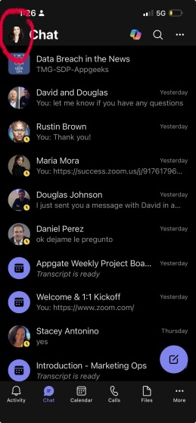
- Go to Setting
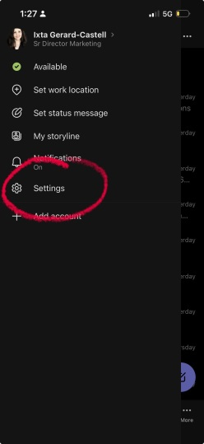

- Select Calling
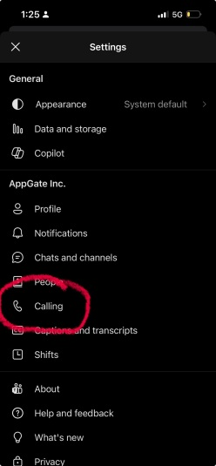

Look for Noise Suppression (it might take time to load on your screen)
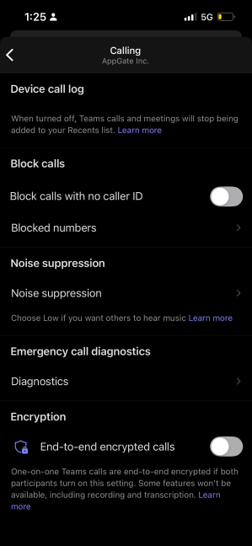

5. Select Low

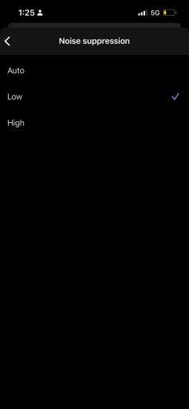

Meeting #2: (no first year students)
We will do this meeting on Tuesday evening. Below are the signup times. We will be doing Daphnis. Have your music, metronome, and instruments ready to go before you join the meeting. Please send me a text, not an email, to let me know what time you want. 847-271-4655

5:00
5:20
5:40
6:00
6:20
6:40
7:00
7:20
7:40
8:00
8:20
8:40
9:00
9:20
9:40

Meeting #3: (no first year students)
We will do this meeting on Wednesday. Below are the signup times. We will be doing Bugler’s Holiday & your ragtime accompaniment. Please send me a text, not an email, to let me know what time you want. 847-271-4655

5:00
5:20
5:40
6:00
6:20
6:40
7:00
7:20
7:40
8:00
8:20
8:40
9:00
9:20
9:40

Meeting #4: (no first year students & only if necessary)
We will do this meeting on Thursday. Below are the signup times. We will address anything that was not prepared in meeting #2 and #3. Please send me a text, not an email, to let me know what time you want. 847-271-4655

5:00
5:20
5:40
6:00
6:20
6:40
7:00
7:20
7:40
8:00
8:20
8:40
9:00
9:20
9:40

